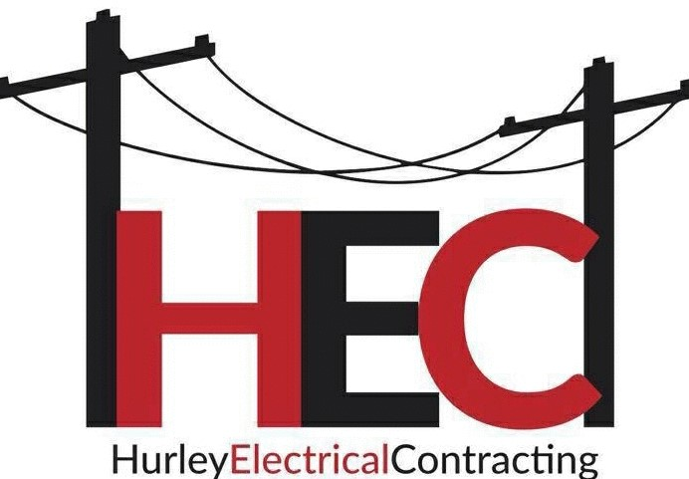Need storm restoration help?  Who We Are:  Hurley Electrical Contracting is a proud family owned company with more than 50 years of combined line building experience. HEC specializes in OSP aerial construction and overhead distribution of power lines. We take pride in our ability to provide certified crews with quality production with the health & safety of our customers and employees being our top priority.  VISIT US:  What we do with power:  - Distribution  - Rebuilds  - Reconducts  - Maintenance  - Pole Setting  - Right of Away Clearing  What we do for telecommunications:  - Aerial Outside Plant Production  - Wreck out  - Pole Setting  - Transfers  - Right of Away Clearing  - Installs  - Debris Removal  - Tree Cutting  www.hurleyelectricalcontracting.net  LIKE US ON FACEBOOK  FOLLOW US ON INSTAGRAM  FOR MORE INFORMATION  EMAIL:  hec@hurleyelectriclcontracting.net  1-606-436-4321  1315 Coalfields Industrial Road  Chavies, Kentucky 41727  - Safety Oriented  - Outside Plant Production  - 50 years of line building experience  - Working Contractors  - Emergency and Storm relief  - Certified Lineman  - OSHA Certified  - Safety Zone/Traffic Safety Certified employees  - Drug Free Workplace  - Traffic Safety Certified  - First Aid/CPR Certified  BUILDING A BRIGHTER TOMORROW. | 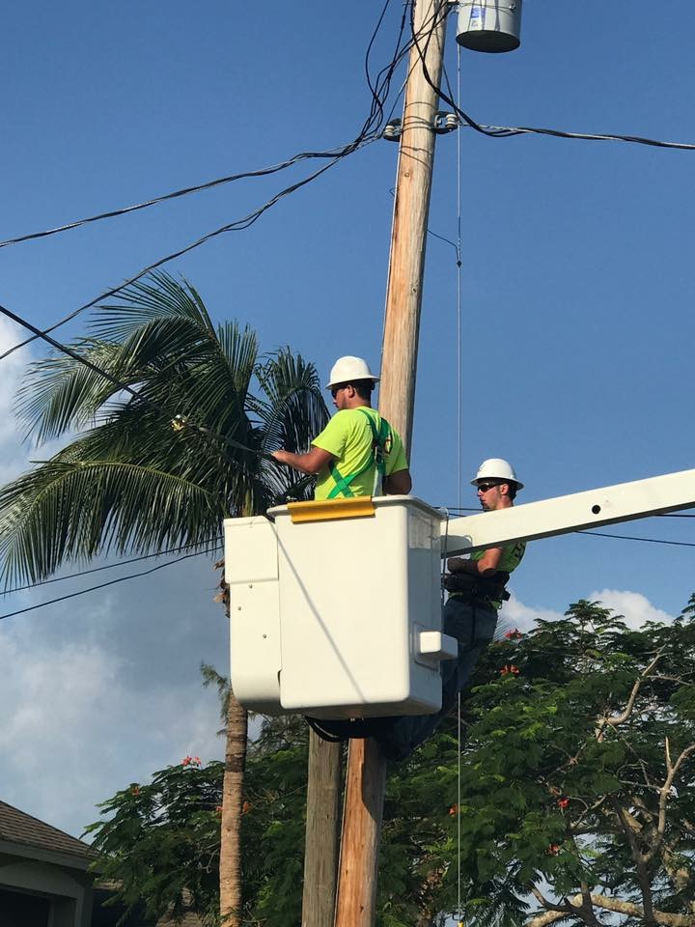  ────  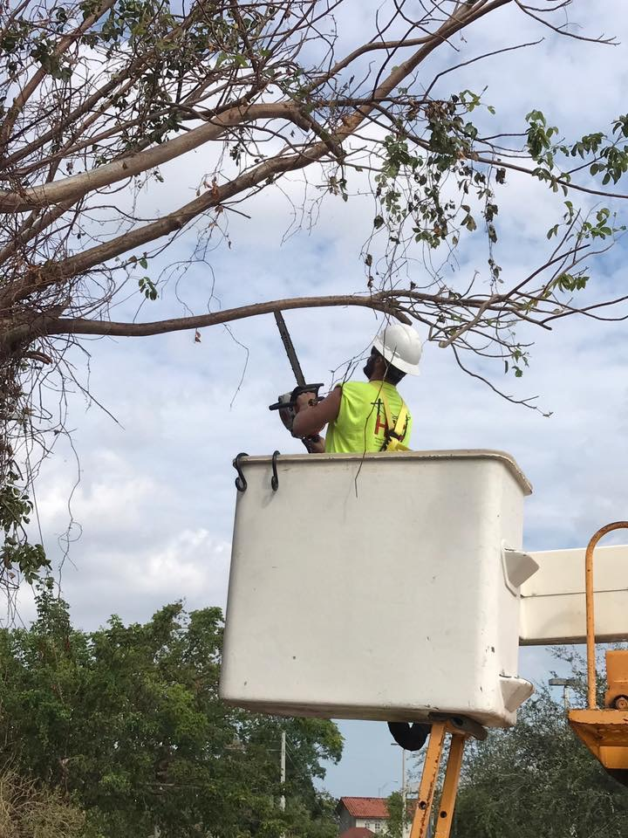  ────  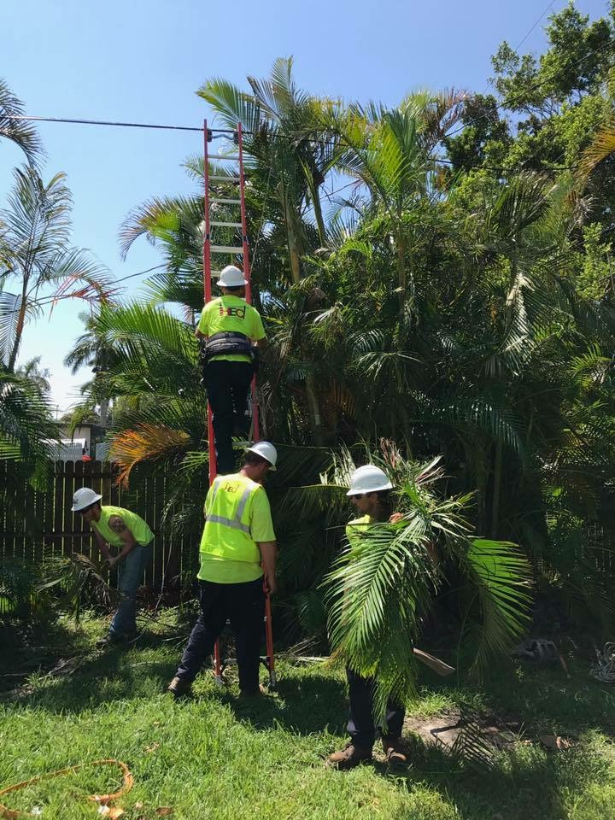  ────  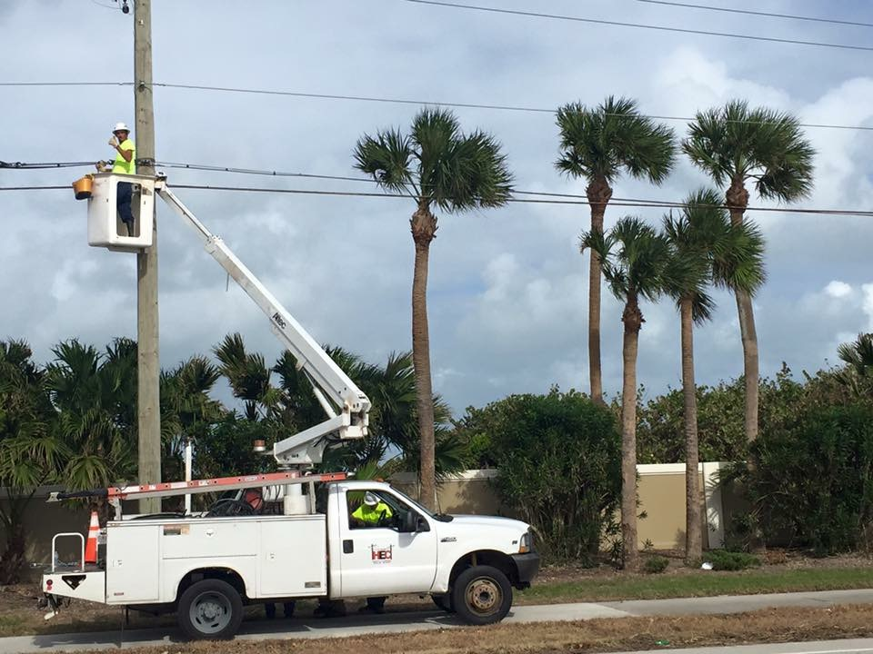  ────  Company Name  Street Address  City, ST ZIP Code  Telephone  Web Address  Dates and Times

